Confidential Referral

Please read ‘REFERRER INFO’ on our website here before completing form:
https://www.viewpointcentre.org/method
We ask that referrers complete this referral form from their own observations rather than the participant’s perspective. We will be asking for similar follow up information on all participants, 8 weeks post course.
All boxes need to be completed.

Name |  | Date
Age/DOB |  | Referred by
Gender |  | Organisation
School/residential |  | Referrer E-mail
Participant Postcode |  | Referrer Phone
Participant shoe size
GDPR: do you have consent or other lawful basis to share this data?
How is this course being funded? (Please give contact details for invoicing, or discuss charitable options with us)
Other agencies involved? E.g. CAMHS, DFM
Mental Health diagnosis?/ other diagnosis?
What talk-based support or other provision has been offered?
Our service is for people for whom talking is not working. Please could you describe the problem, e.g.: disengaged / non-responsive / "stuck" / ..

Can we stay in touch with referrer
for evaluation/research purposes?
Has Participant/Parent completed a consent form?
Risks we should know about? (re. safeguarding the participant or re. our own safety):

Parents have agreed to come with child if under 18 to observe sessions and participate in a couple of non horse based tasks throughout the week? Do contact us to find out options if needs be. Y/N
Parents have/are booking the Non Verbal Toolkit Training 2 hour workshop direct? Y/N

Please consider risk assessments for supporting family on their suitability to have unsupervised access to our premises. Please note:
- There may be other vulnerable young people on the premises, consider safeguarding issues
- The environment contains unsupervised horses and equipment
- We only have skeleton staffing – we supervise participants but cannot supervise other visitors
- Good relations with our neighbours is essential
Our premises are under 24 hour CCTV video surveillance.

Please consider the THC Star overleaf and rate the candidate's current levels according to your own impressions. Star Scores: From 0=Stuck to 4=Competent, in 8 areas - see key on star.
Assertiveness / Boundaries |  | Calmness
Focus & Perseverance |  | Realistic Planning / Analysis
Taking Responsibility |  | Communication & Language
Relating to Others / Empathy |  | Engagement / Learning

Poor engagement with Education/Training/Work?

Problem Behaviours: (e.g. drug, alcohol, offending, mental health diagnoses, homelessness, eating disorders, disruptive, bullying, isolated…)
Problems with Relationships? (family, peers, professionals)
Identity (e.g. low self esteem, poor self image, lacks hope, ambition, self belief):
Any specific outcomes you hope for?

Privacy Notice
Viewpoint Centre controls data in accordance with the Data Protection Act 1998 and General Data Protection Regulation 2018. Our Data Protection Policy is available on request, detailing retention periods and rectification processes.

The purpose of this form is to obtain referral information regarding the participant named and contact information for the person referring them into our service. This information will be used only for the purposes for which it is given. We will seek consent for all our data processing from the participant upon first contact.

As a charity we rely on funding to keep our courses running - how you can help:

      - Play the Tandridge Together Lottery - a fun and easy way to support Viewpoint Centre for as little as £1 a week with some fab prizes up for grabs.
      - Donate 0.5% of your Amazon purchases to Viewpoint Centre by switching over to Amazon Smile and selecting us.
      - Make a one off donation via Paypal.
      - Organise a fundraiser/donate your business services or gift raffle prizes.
Please go to https://www.viewpointcentre.org/donate
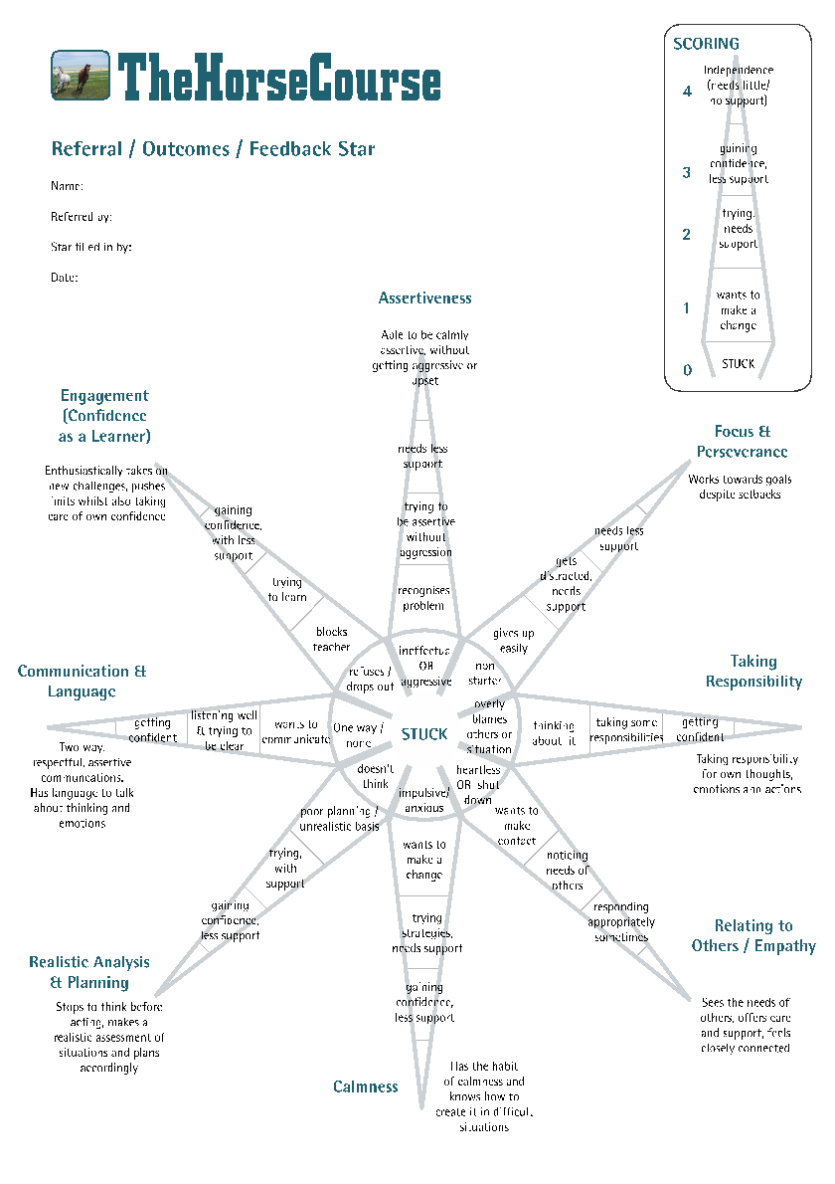

Registered charity no. 1172302
Viewpoint Stables, Moons Lane, Dormansland, Surrey, RH7 6PD - 0300 772 9692 - info@viewpointcentre.org

